SE-2004 Database Systems Lab BSSE-4A2

**SEMESTER PROJECT REPORT**

**CAR DEALERSHIP**

**Group Members:**

**Muhammad Hamza Khalid SE-201028**

**Syed Ali Sarwar SE-201039**

* **Introduction:**

Car dealership is place where you can book, visit ,buy or sell your car easily .We deals in all luxury cars you can easily register with our systerm,so you will get updated daily by our newsletters we deliver car to you home ,if your cars does not doing good we offer you best service in the town you can easily book service at your home form our portal

* **Scope:**
* **Admin**

As a admin we can control each and every thing, set prices add or remove customers employee and products ,view all orders all inventory

* **Customers**

Easily signup and login sell buy view cars book service and can do much more

* **Module Description:**

A car dealership company provides service of call selling and purchasing car.

Main actors are mechanic,sellperons customers and the product it self ,we provide customer to login or signup,we provide him a id,he or she then can easily view cars form car menu by 4 ways by ID,color,brand and by make year.A salesperson may sell many cars, A customer may buy many cars, but each car is bought only by valid customer.A salesperson writes a single invoice for each car he or she sells.A customer gets an invoice for each car he or she buys.A customer may come in just to have his or her car serviced; that is, a customer need not buy a car to be classified as a customer.we also provide best service to our customers and we have highly professional mechanics

* **Hardware/Software Requirements**

**Hardware Requirements:**

1. Processor: 2.5Ghz required.
2. Memory (RAM): 2 gb or above required.
3. Storage: At least 100mb required.

**Software Requirements:**

1. Windows 7,8,10 and 11 required.
2. All windows drivers must be updated.
3. JDK

**4.1 Tools:**

1. Java IDE
2. Wamp,Zamp or mysqlworkbench

**4.2 Libraries , IDE:**

import java.sql.ResultSet;  
import java.sql.SQLException;  
import java.text.ParseException;  
import java.text.SimpleDateFormat;  
import java.time.LocalDateTime;  
import java.time.format.DateTimeFormatter;  
import java.util.Date;  
import java.util.Scanner;

1.Intellij

1. Netbeans
2. Eclipse

**Screen Shots**

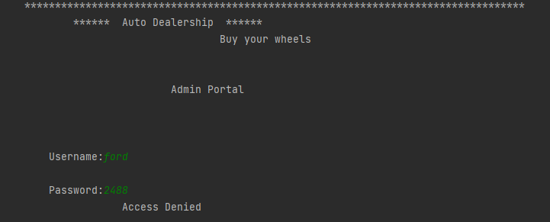

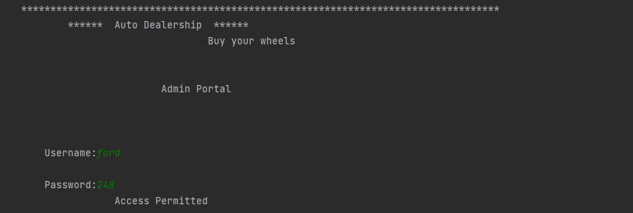

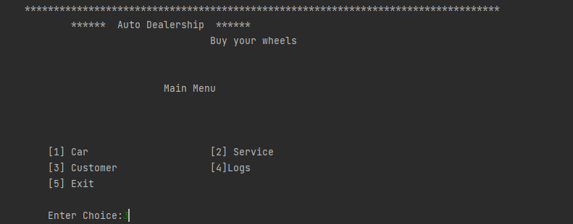 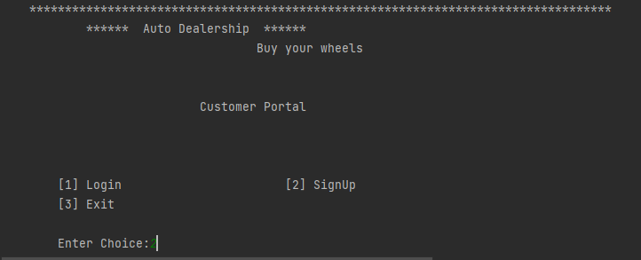 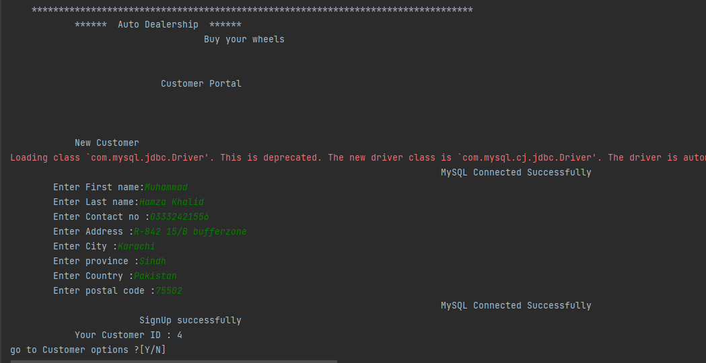 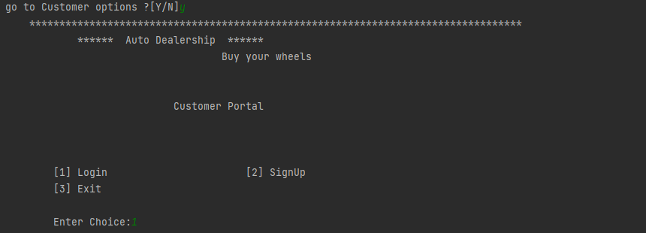

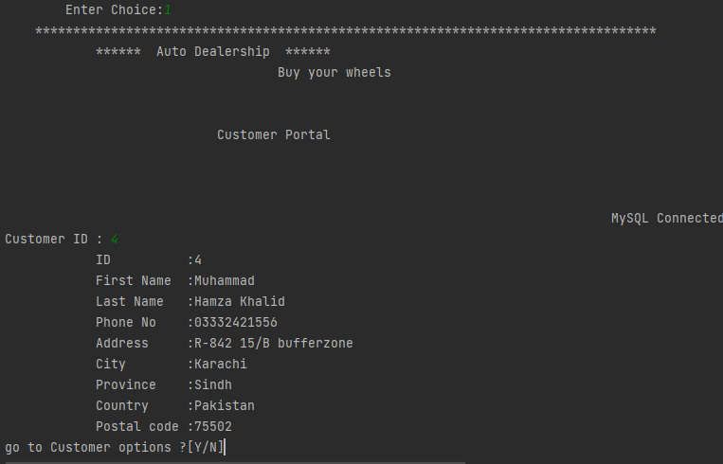 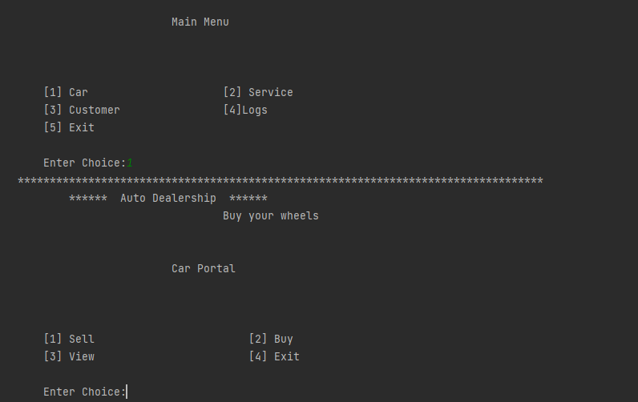

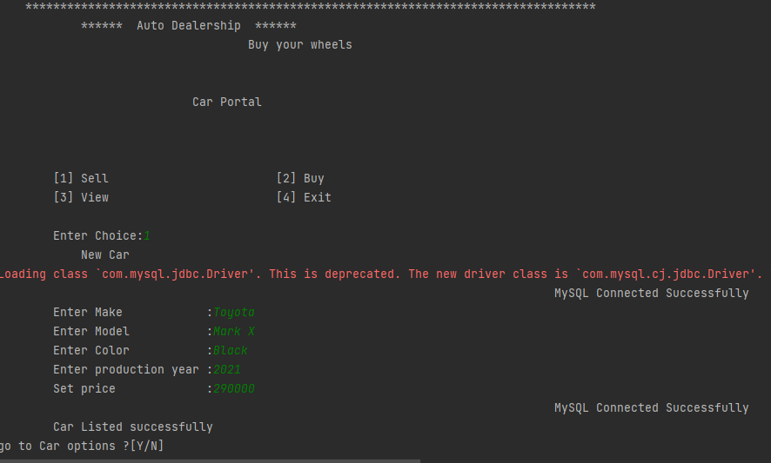 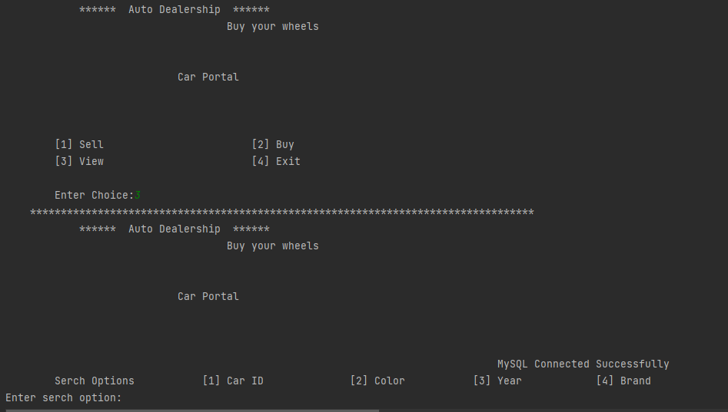 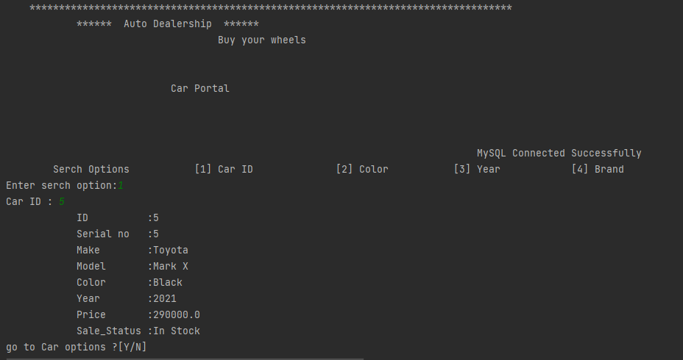 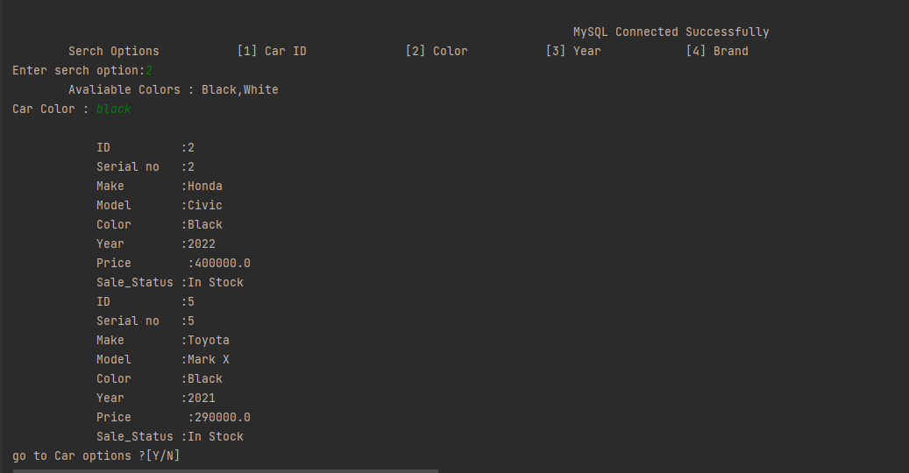 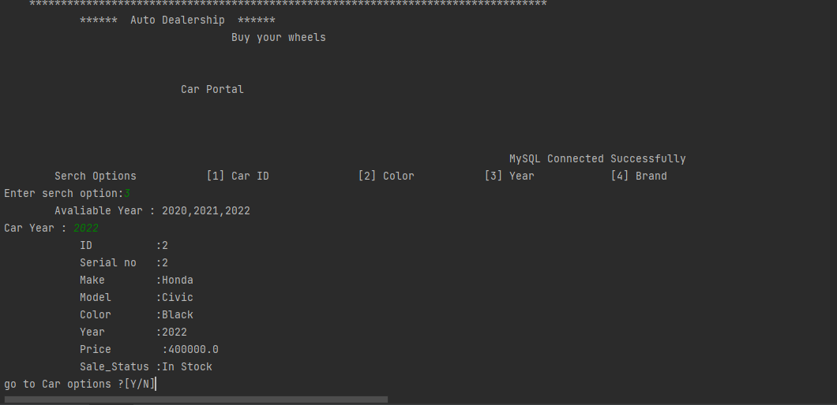 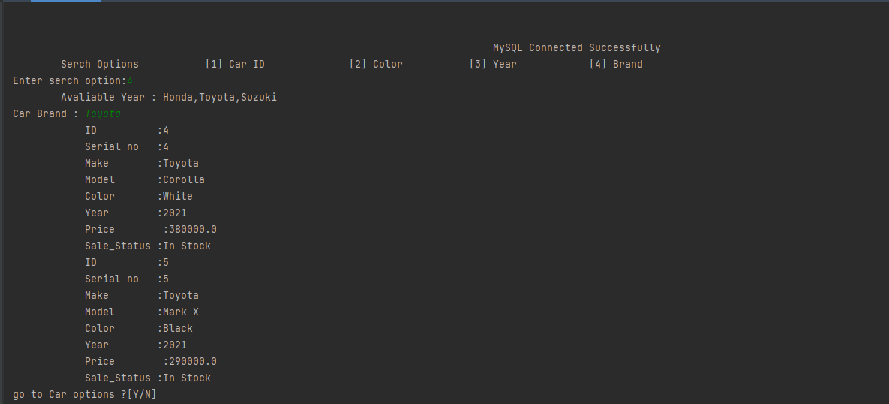 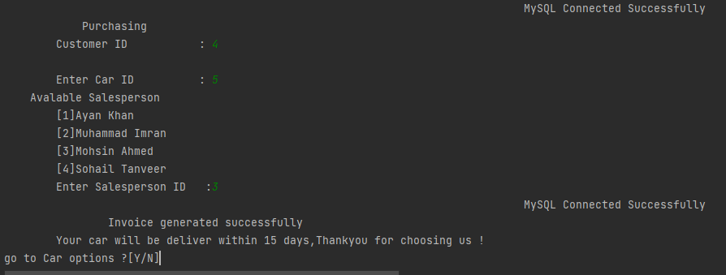 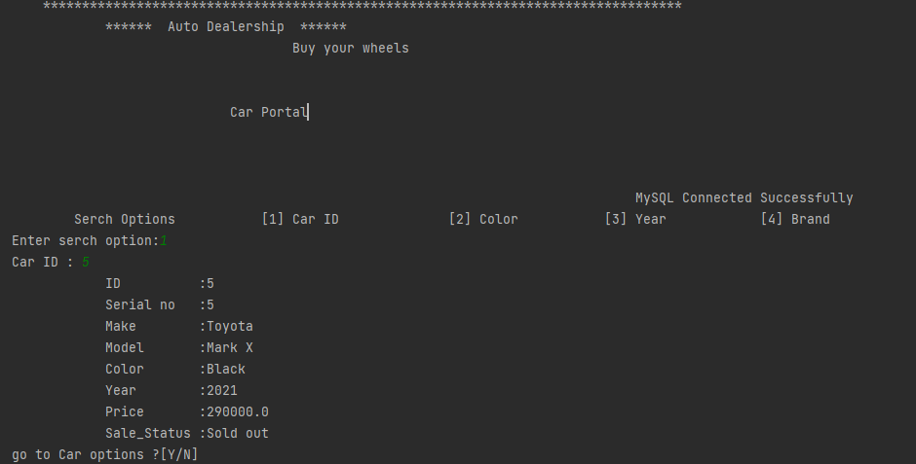

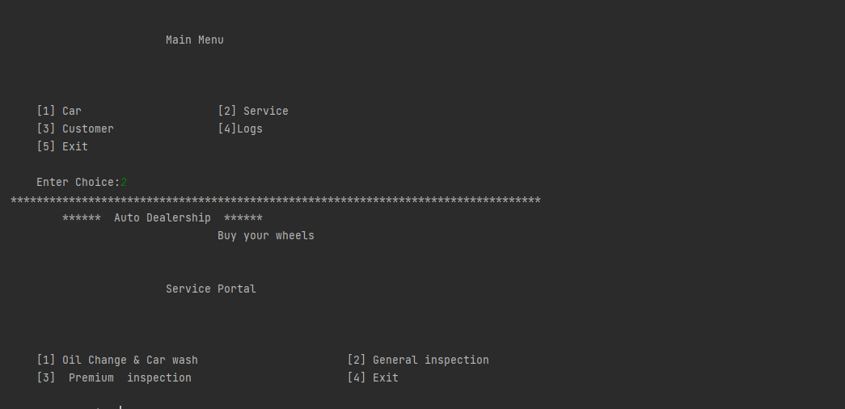 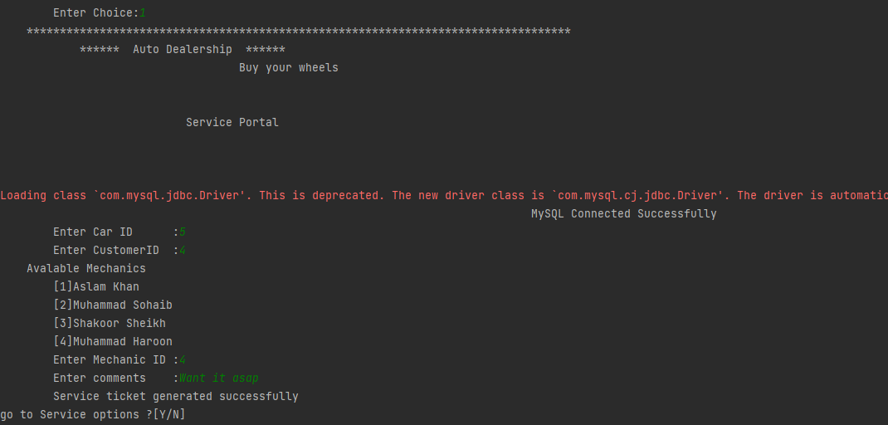 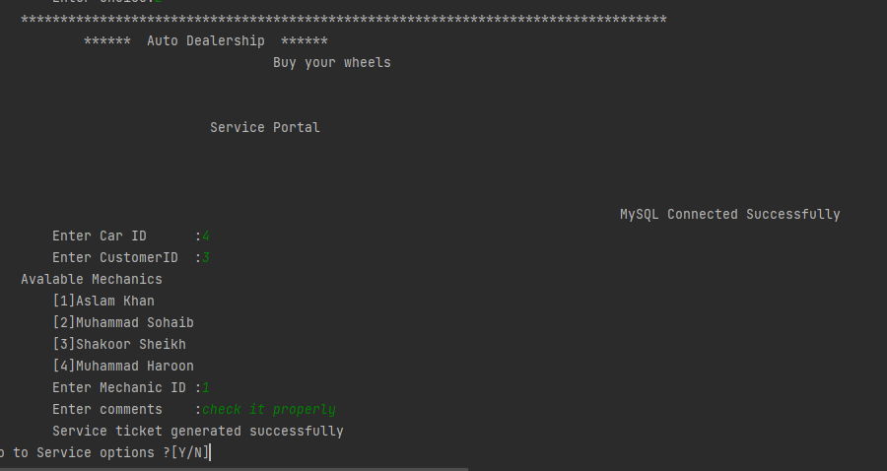 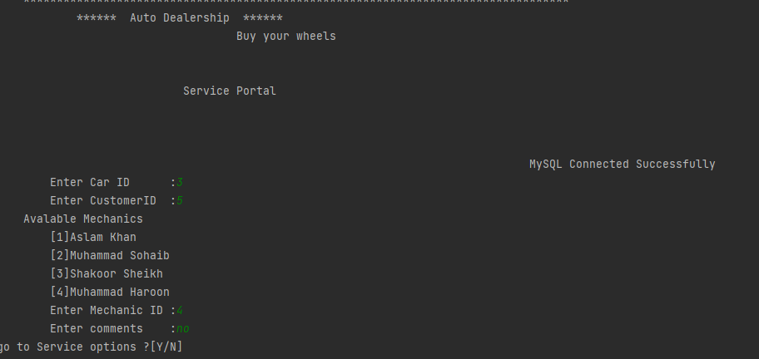

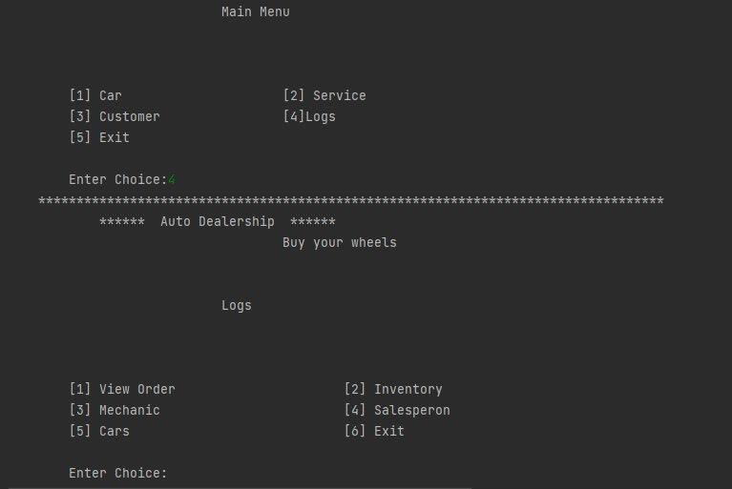 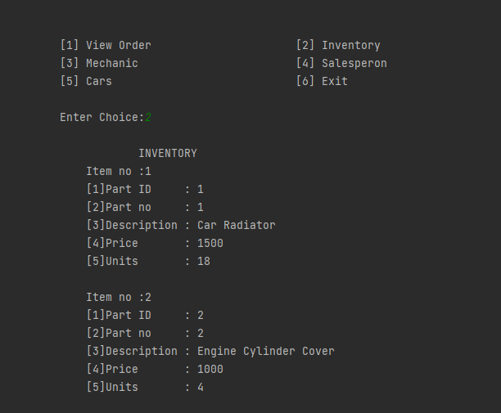 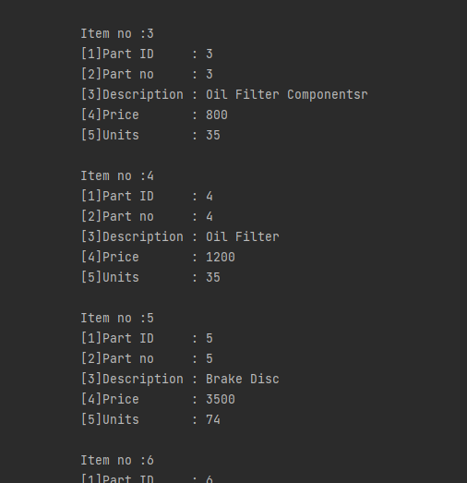 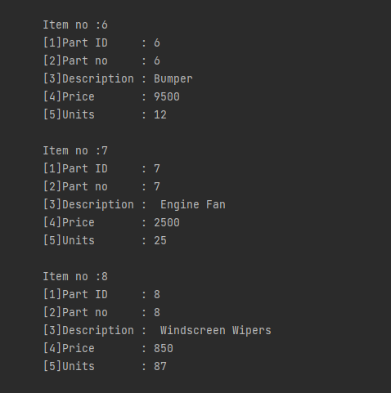 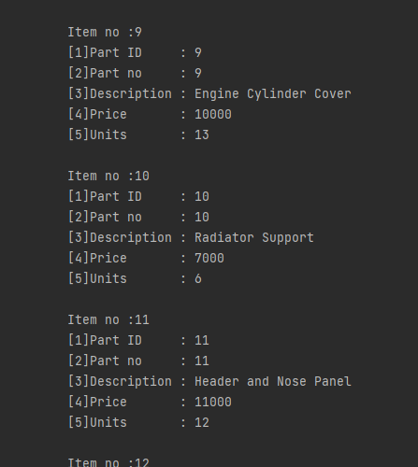 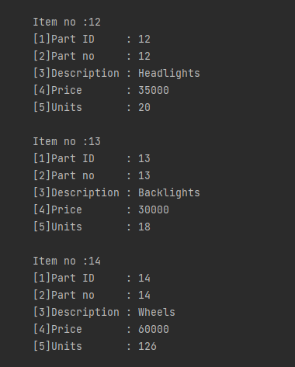 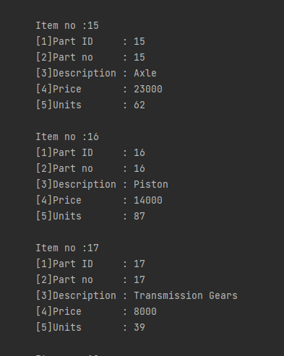 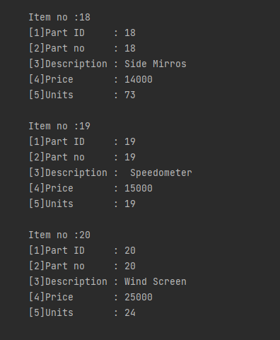 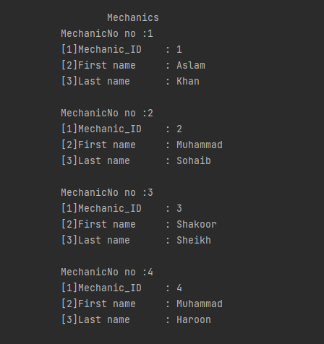

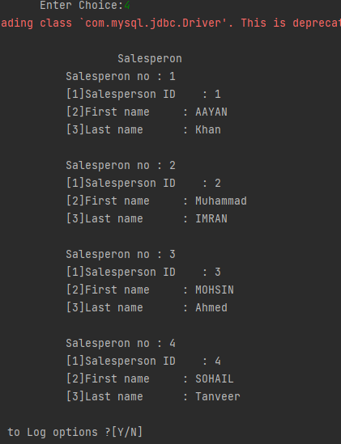 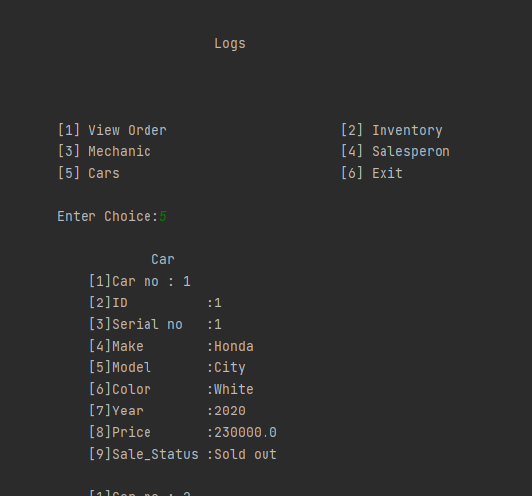 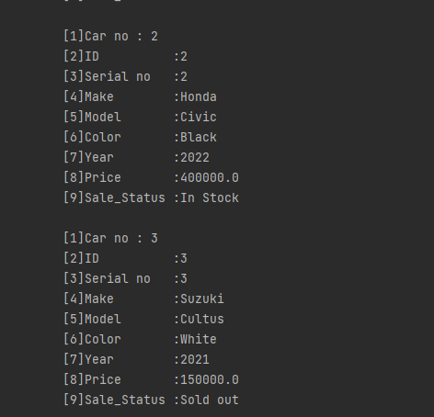 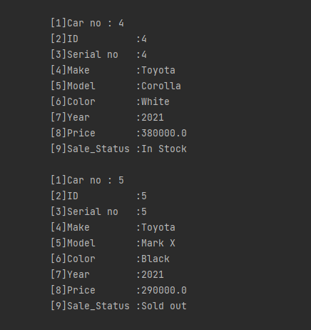 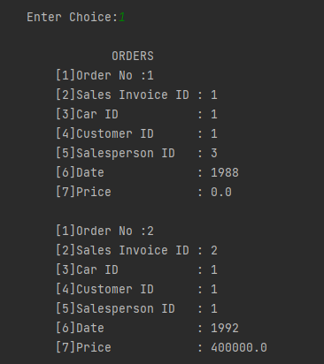 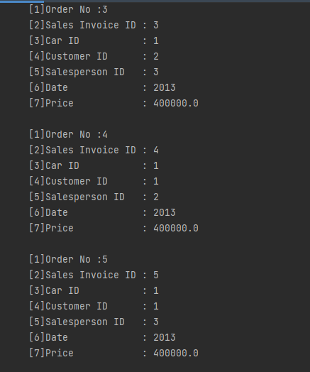 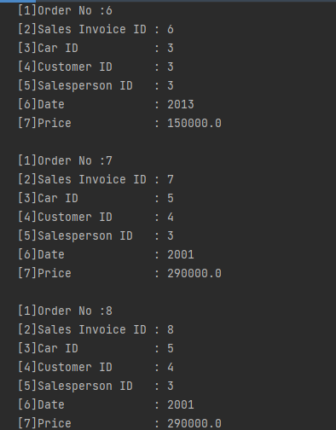

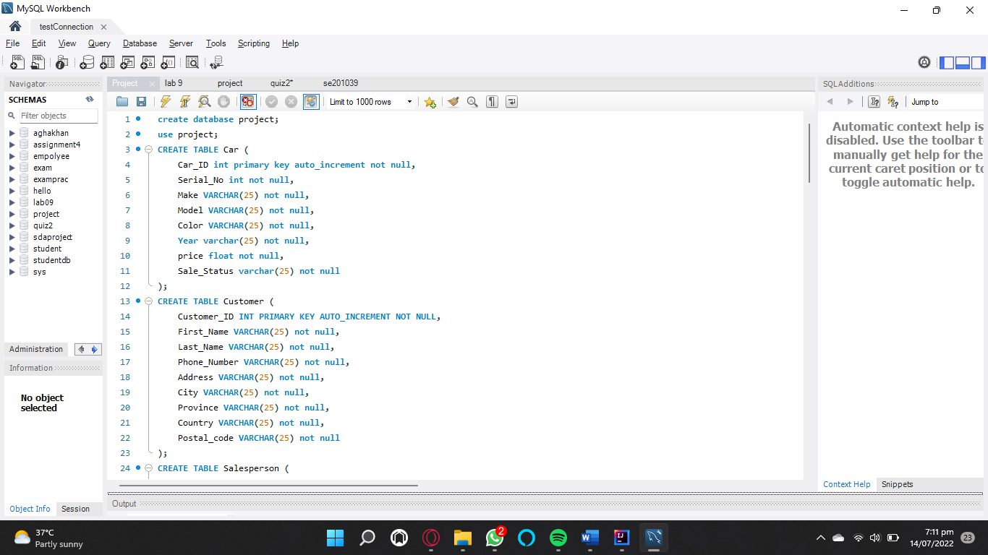 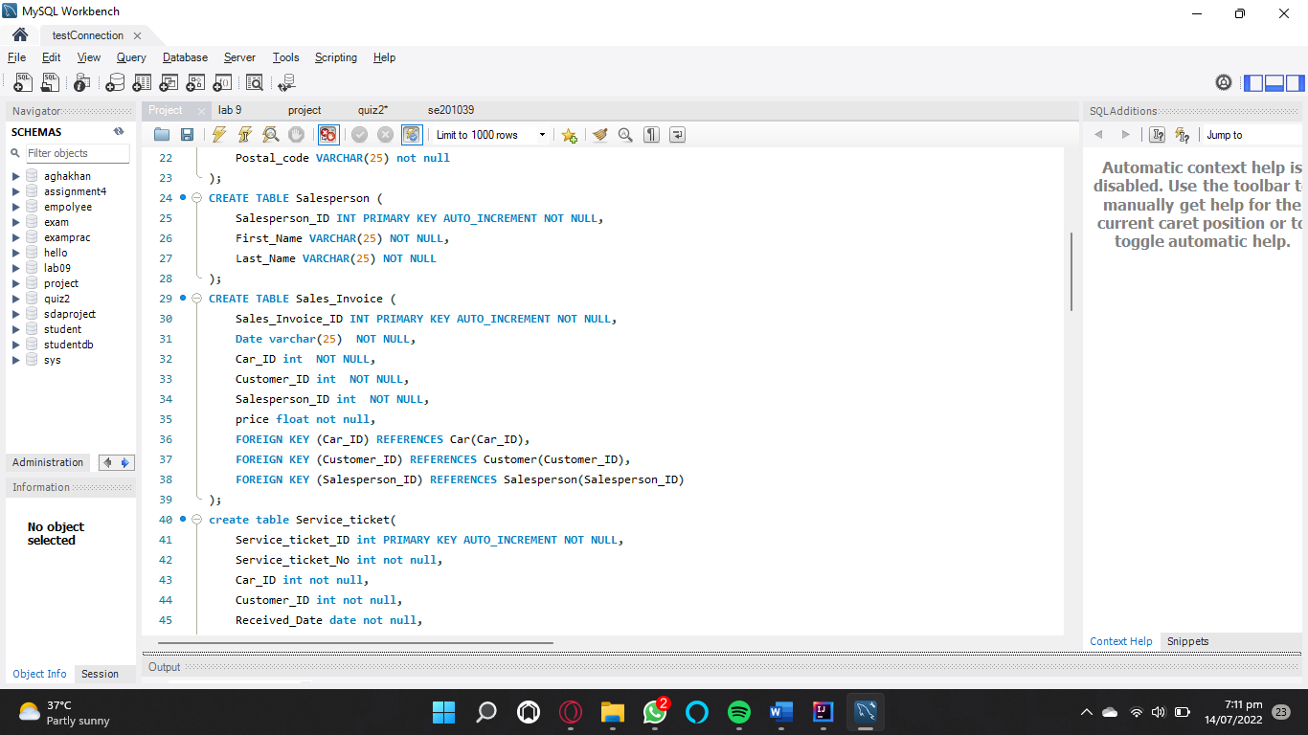 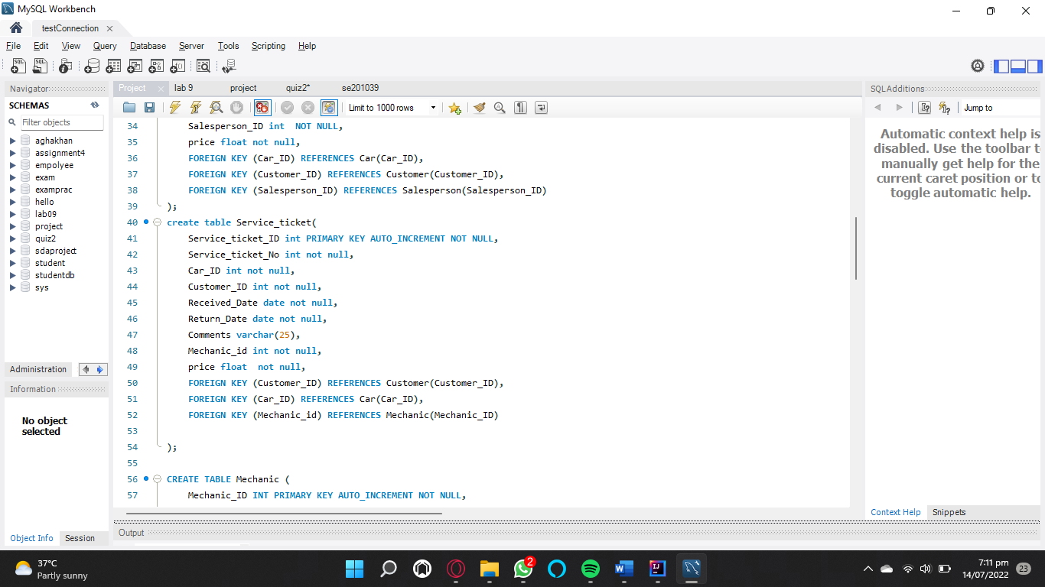 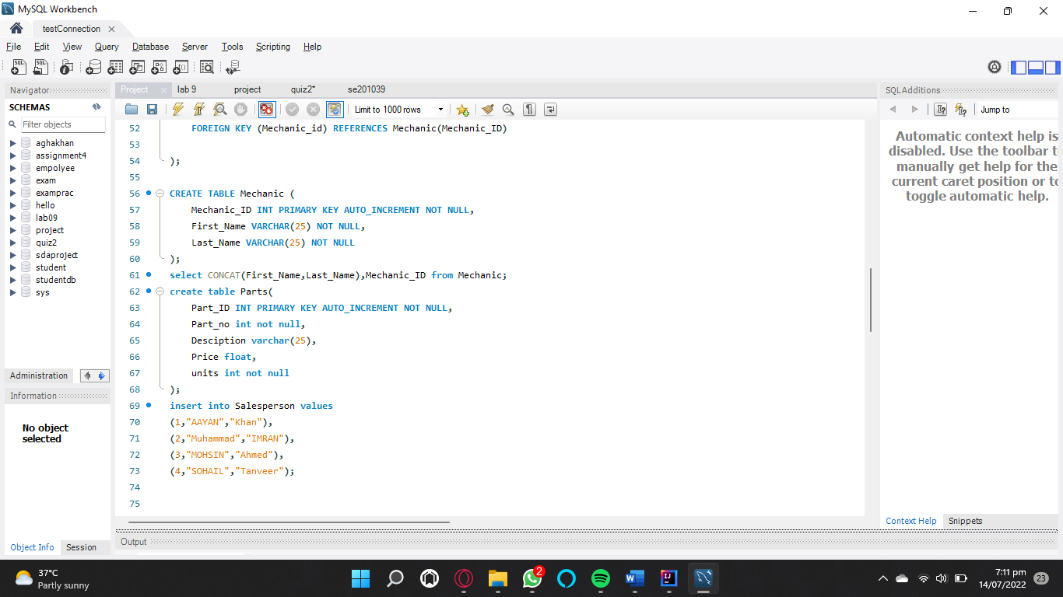 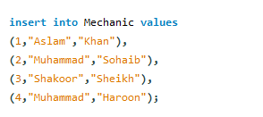 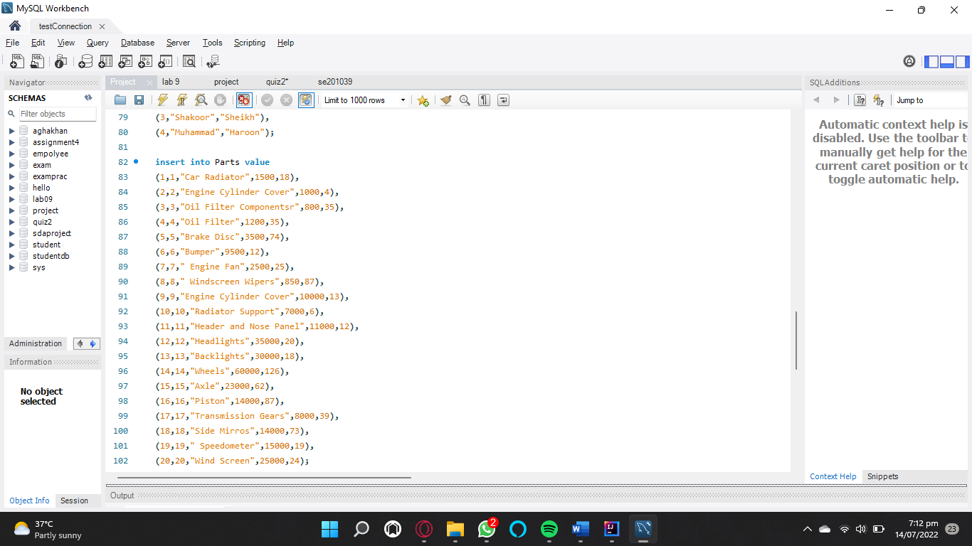 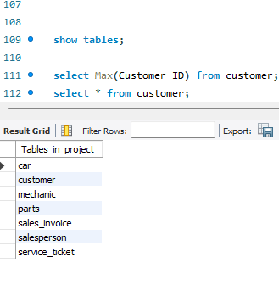 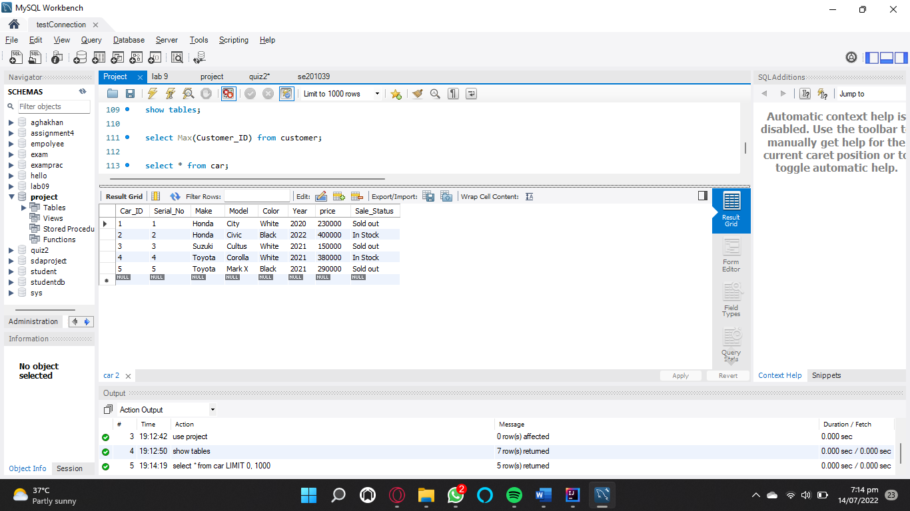 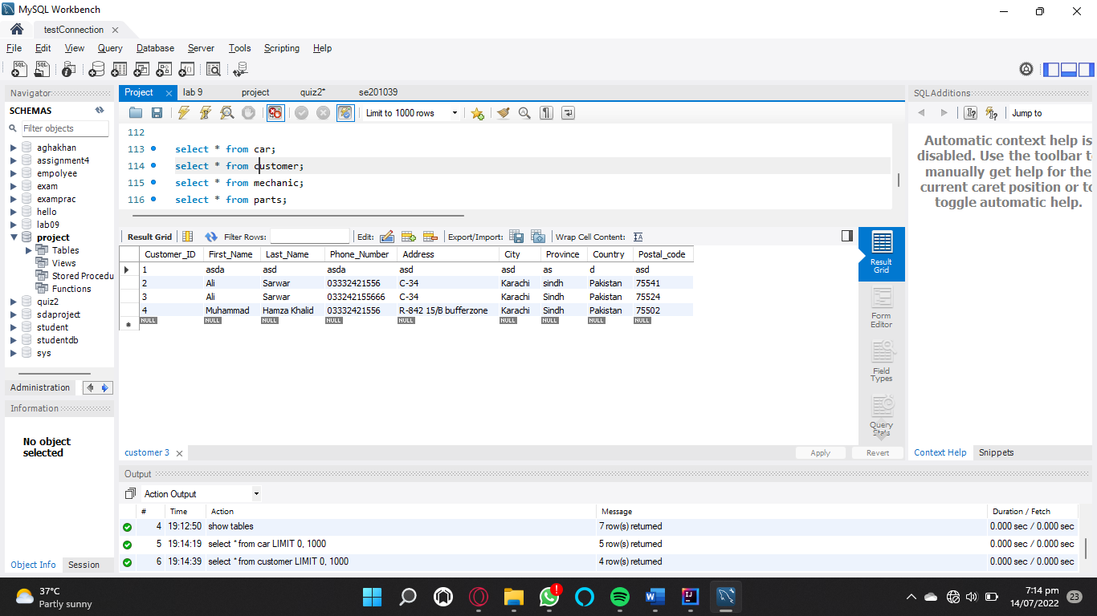 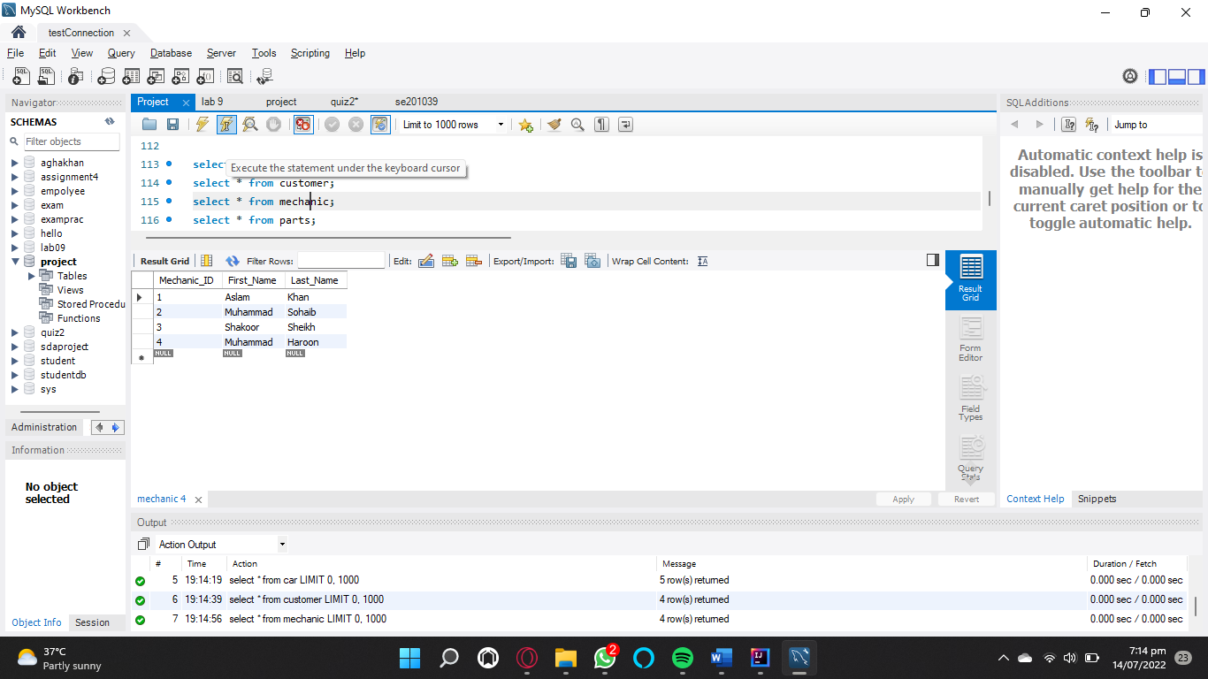 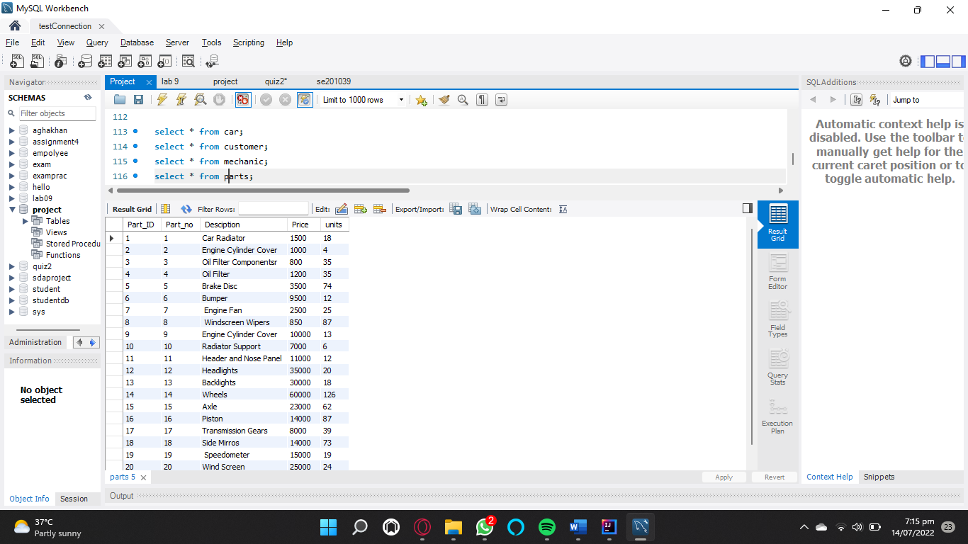 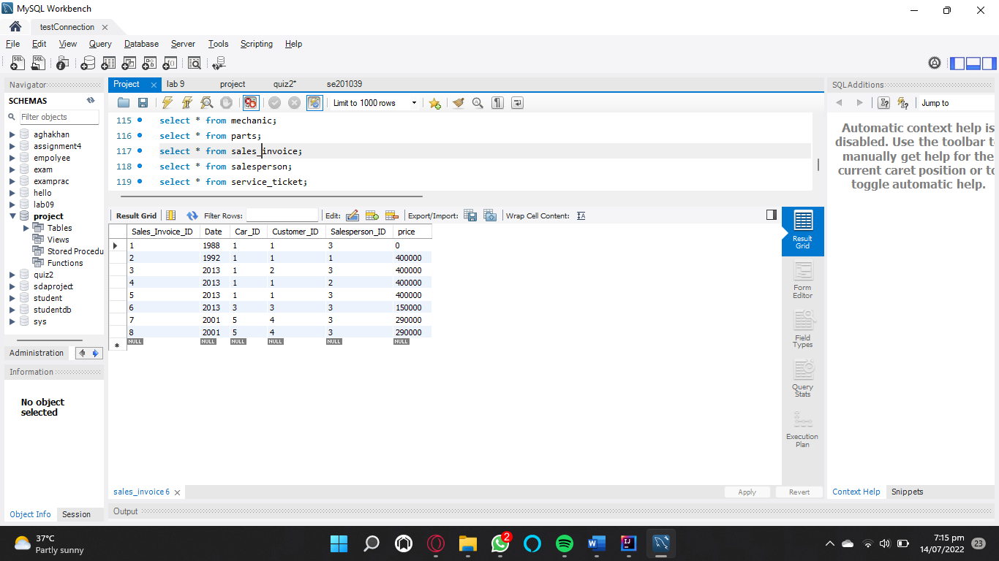 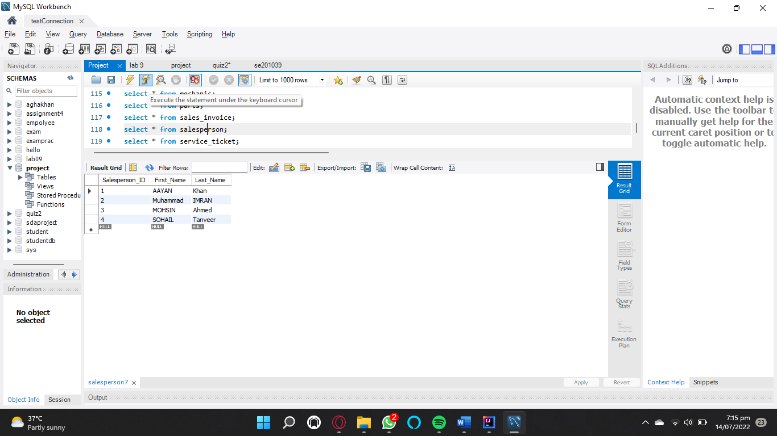 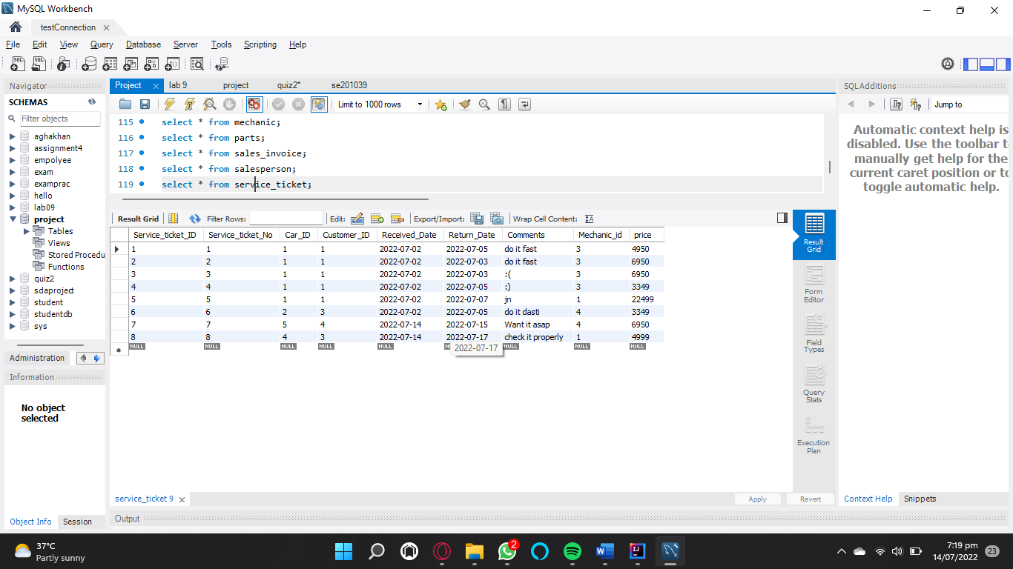

**ER Diagram**

